CHAPTER 1
PROJECT DESCRIPTION
1.1 INTRODUCTION
Urban infrastructure, especially drainage and sewage systems, plays a critical role in maintaining public health and safety. However, manholes and underground pipelines often pose serious hazards due to accidental openings, unauthorized access, or accumulation of toxic gases. Traditional monitoring and inspection methods are largely manual, time-consuming, and prone to human error, which increases the risk of accidents for both maintenance workers and pedestrians. With the rapid growth of cities and increasing urban population, there is a pressing need for an automated, reliable system that can provide real-time monitoring of manholes to prevent accidents, detect hazardous conditions, and ensure worker safety.
The Manhole Monitoring System leverages an Arduino Uno-based embedded platform integrated with multiple sensors to continuously track various environmental parameters. Infrared (IR) sensors are employed to detect whether manhole covers are open or closed, while MQ-series gas sensors monitor the concentration of harmful gases such as CO₂ and methane. A water level sensor provides alerts for potential flooding or blockages. The system is designed to trigger immediate alarms through a buzzer and display real-time sensor data on an I2C LCD screen, allowing on-site personnel to quickly assess and respond to critical situations. By combining multiple sensors and automated alert mechanisms, the system minimises the dependency on manual inspections and ensures rapid hazard detection.
Furthermore, the system supports remote monitoring and integration with IoT platforms, GSM modules, or cloud-based services, allowing municipal authorities to supervise multiple locations simultaneously. This connectivity ensures that timely alerts and notifications reach authorized personnel, enabling proactive measures to prevent accidents or infrastructure damage. The modular and scalable design of the project also allows for future enhancements, including advanced analytics, predictive maintenance, and worker health monitoring. Overall, this project represents a practical and cost-effective approach to modernizing urban safety systems, reducing risks, and improving operational efficiency in public infrastructure management.

1.2 EXISTING SYSTEM
The current systems for hazard detection in urban settings primarily focus on domestic gas leakage and emergency alerts rather than comprehensive manhole monitoring. These systems are designed to detect combustible gases such as LPG within household environments and automatically activate alarms when dangerous concentrations are sensed. The alerts are usually sent to licensed users or household members via signal or message notifications, allowing them to take corrective action quickly. Some systems also include mechanisms to control gas flow, such as activating relays or motors to shut off cylinders when leakage is detected. While effective in managing domestic gas hazards, these systems are limited in scope and primarily target a single type of environment, leaving industrial and municipal infrastructure largely unmonitored.
Moreover, existing detection systems are constrained by their portability, cost, and implementation complexity. Most commercially available solutions are bulky, expensive, and difficult to deploy in large-scale urban infrastructure such as manholes or sewage systems. They focus only on detecting a few types of gases and do not provide comprehensive environmental monitoring, such as water levels or worker health conditions. Consequently, these systems are inadequate for municipal applications, where multiple hazardous parameters must be continuously monitored to prevent accidents and protect maintenance personnel. This highlights the need for a more versatile, cost-effective, and scalable solution capable of monitoring manholes in real time while providing automated alerts and health monitoring for workers.
DISADVANTAGES
- Existing systems are designed to detect only a few types of gases making them unsuitable for monitoring diverse hazardous gases like CO₂ or methane in manholes.
- Most current systems are bulky and not easily deployable in multiple urban locations.
- Commercially available solutions tend to be expensive, making large-scale deployment across numerous manholes economically challenging for municipalities.
- Current systems are primarily developed for domestic environments and do not address the specific needs of manholes, sewage lines, or industrial areas, leaving critical urban infrastructure unmonitored.
- Solutions do not provide comprehensive monitoring, such as water levels, worker health, or real-time alerts, reducing their effectiveness in preventing accidents and ensuring safety.

1.3 PROPOSED SYSTEM
The proposed system focuses on designing a comprehensive, automated solution for monitoring manholes and ensuring worker safety using an Arduino-based embedded platform. Unlike existing domestic gas detection systems, this project integrates multiple sensors to track various environmental parameters in real time. The system employs IR sensors to detect whether a manhole cover is open or closed, MQ-series gas sensors to monitor the presence of hazardous gases such as CO₂ and methane, and water level sensors to identify potential flooding or blockages.
All sensor data is processed by the Arduino microcontroller and displayed on an I2C LCD screen, providing field personnel with real-time insights into environmental conditions around the manhole. In addition to local monitoring, the system supports automated alerts and remote supervision. If any sensor detects abnormal conditions, a buzzer immediately triggers a local alarm, while sensor readings and alert statuses are transmitted via NodeMCU to an authorized receiver. This ensures that municipal authorities or maintenance supervisors can monitor multiple manholes remotely and respond promptly to hazardous situations. The modular architecture of the system allows easy integration with IoT platforms, GSM modules for SMS notifications, or cloud-based monitoring systems, enhancing the scalability and flexibility of the solution.
Moreover, the proposed system prioritizes worker safety by integrating health monitoring features alongside environmental detection. For instance, worker heart rate and exposure to toxic gases are continuously monitored, with alerts generated if thresholds are exceeded. By combining environmental hazard detection, health monitoring, and automated alert mechanisms, this system eliminates manual inspection inefficiencies, reduces the risk of accidents, and improves the overall operational efficiency of municipal maintenance teams.
ADVANTAGES
- Eliminates the need for manual measurements and monitoring processes.
- Provides real-time monitoring of worker safety with high accuracy.
- Integrates all parameters into a single, easy-to-use system.
- Offers quick response time and accurate detection of hazardous conditions.
- Enables faster emergency alerts, reducing the impact of critical situations.

1.4 SYSTEM REQUIREMENTS
- HARDWARE SPECIFICATION
- NodeMCU
- Gas Sensor - CO2
- Gas Sensor – CH4
- Humidity Sensor
- Power Supply +5V and +12V

- SOFTWARE SPECIFICATION
- Operating System : Windows OS 10
- IDE : Arduino IDE 1.8.13

CHAPTER 2
LOGICAL DEVELOPMENT
2.1 DFDs
A two-dimensional diagram explains how data is processed and transferred in a system. The graphical depiction identifies each source of data and how it interacts with other data sources to reach a common output. Individuals seeking to draft a data flow diagram must identify external inputs and outputs, determine how the inputs and outputs relate to each other, and explain with graphics how these connections relate and what they result in. This type of diagram helps business development and design teams visualize how data is processed and identify or improve certain aspects.
Data flow Symbols:
Symbol | Description
 | An entity. A source of data or a destination for data.
 | A process or task that is performed by the system.
 | A data store is a place where data is held between processes.
 | A data flow.
Table 1
LEVEL 0
The Level 0 DFD shows how the system is divided into 'sub-systems' (processes), each of which deals with one or more of the data flows to or from an external agent, and which together provide all of the functionality of the system as a whole. It also identifies internal data stores that must be present in order for the system to do its job, and shows the flow of data between the various parts of the system.

Sensor
SMS

NodeMCU
Check the Threshold

Monitoring
Fig.2.1 Structure Diagram

LEVEL 1
The next stage is to create the Level 1 Data Flow Diagram. This highlights the main functions carried out by the system. As a rule, to describe the system was using between two and seven functions - two being a simple system and seven being a complicated system. This enables us to keep the model manageable on screen or paper.

NodeMCU
Input Sensor
GAS
COVER STATUS
Check Data

SMS & BUZZER
SMS & BUZZER
WATER LEVEL
SMS & BUZZER
Fig.2.2 Data Flow Diagram

2.2 ARCHITECTURAL DESIGN
The architecture of the Manhole Monitoring System is designed around a central NodeMCU microcontroller that integrates multiple sensors and output modules to monitor environmental and safety conditions. The system receives power from a dedicated power supply and continuously collects data from an IR sensor to detect manhole cover status, a CO₂ gas sensor to monitor hazardous gas levels, and a water level sensor to identify potential flooding or overflow. When abnormal conditions are detected, the NodeMCU triggers a buzzer for immediate local alerts. Simultaneously, sensor readings are transmitted through a WiFi module to send SMS alerts to authorize personnel, enabling remote monitoring and quick response. This architecture ensures real-time detection, automated alerting, and effective communication for improved urban safety.
IR
NodeMCU

WATER LEVEL
CO2 Sensor
Power Supply
SMS
WiFi
BUZZER
Fig.2.3 Architecture Diagram

CHAPTER 3
HARDWARE DESIGN
- Power Supply
A power supply (sometimes known as a power supply unit or PSU) is a device or system that supplies electrical or other types of energy to an output load or group of loads. The term is most commonly applied to electrical energy supplies, less often to mechanical ones, and rarely to others.
This circuit is a small +5V power supply, which is useful when experimenting with digital electronics. Small inexpensive wall transformers with variable output voltage are available from any electronics shop and supermarket. Those transformers are easily available, but usually their voltage regulation is very poor, which makes then not very usable for digital circuit experimenter unless a better regulation can be achieved in some way. The following circuit is the answer to the problem.
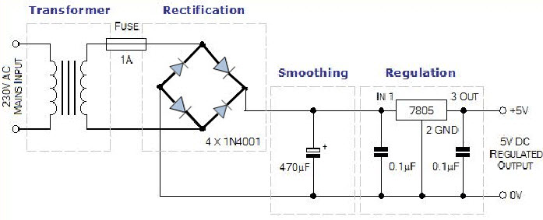
Fig. 3.1 5V Power Supply
- Transformer
A transformer is a device that transfers electrical energy from one circuit to another through inductively coupled wires. A changing current in the first circuit (the primary) creates a changing magnetic field; in turn, this magnetic field induces a changing voltage in the second circuit (the secondary). By adding a load to the secondary circuit, one can make current flow in the transformer, thus transferring energy from one circuit to the other. The secondary induced voltage V_{S} is scaled from the primary V_{P} by a factor ideally equal to the ratio of the number of turns of wire in their respective windings:
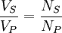
By appropriate selection of the numbers of turns, a transformer thus allows an alternating voltage to be stepped up — by making N_{S} more than N_{P} or stepped down, by making it less.
A key application of transformers is to reduce the current before transmitting electrical energy over long distances through wires. Most wires have resistance and so dissipate electrical energy at a rate proportional to the square of the current through the wire. By transforming electrical power to a high-voltage, and therefore low-current form for transmission and back again afterwards, transformers enable the economic transmission of power over long distances. Consequently, transformers have shaped the electricity supply industry, permitting generation to be located remotely from points of demand. All but a fraction of the world's electrical power has passed through a series of transformers by the time it reaches the consumer.
Transformers are some of the most efficient electrical 'machines', with some large units able to transfer 99.75% of their input power to their output. Transformers come in a range of sizes from a thumbnail-sized coupling transformer hidden inside a stage microphone to huge gigavolt-ampere-rated units used to interconnect portions of national power grids. All operate with the same basic principles, though a variety of designs exist to perform specialized roles throughout home and industry.
The transformer is based on two principles: first, that an electric current can produce a magnetic field (electromagnetism) and, second, that a changing magnetic field within a coil of wire induces a voltage across the ends of the coil (electromagnetic induction). By changing the current in the primary coil, one changes the strength of its magnetic field; since the secondary coil is wrapped around the same magnetic field, a voltage is induced across the secondary.
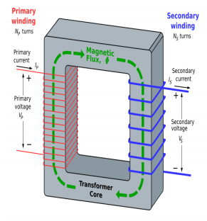
Fig. 3.2 An ideal step-down transformer
A simplified and ideal step-down transformer design is shown in the above figure. A current passing through the primary coil creates a magnetic field. The primary and secondary coils are wrapped around a core of very high magnetic permeability, such as iron; this ensures that most of the magnetic field lines produced by the primary current are within the iron and pass through the secondary coil as well as the primary coil.
- Rectifier
A rectifier is an electrical device that converts alternating current (AC), which periodically reverses direction, to direct current (DC), which flows in only one direction. The process is known as rectification. Rectifiers are used as components of power supplies and as detectors of radio signals. Mainly there are three types of rectifier i.e. half wave rectifier, full wave rectifier and Bridge Rectifier.
- Bridge Rectifier
A diode bridge is an arrangement of four (or more) diodes in a bridge circuit configuration that provides the same polarity of output for either polarity of input. When used in its most common application, for conversion of an alternating current (AC) input into a direct current (DC) output, it is known as a bridge rectifier. A bridge rectifier provides full-wave rectification from a two-wire AC input, resulting in lower cost and weight as compared to a rectifier with a 3-wire input from a transformer with a center-tapped secondary winding. The essential feature of a diode bridge is that the polarity of the output is the same regardless of the polarity at the input.

- Basic operation
According to the conventional model of current flow, current is defined to be positive when it flows through electrical conductors from the positive to the negative pole. In actuality, free electrons in a conductor nearly always flow from the negative to the positive pole. In the vast majority of applications, however, the actual direction of current flow is irrelevant. Therefore, in the discussion below the conventional model is retained.
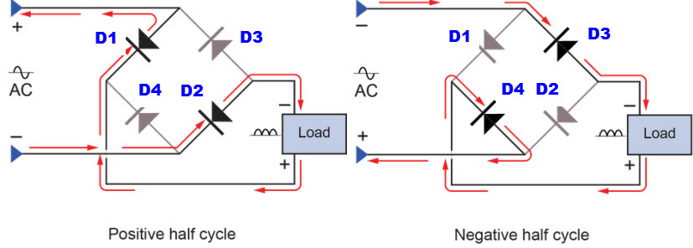
Fig.3.3 Operation of bridge rectifier
In each case, the upper right output remains positive and the lower right output negative. Since this is true whether the input is AC or DC, this circuit not only produces a DC output from an AC input, it can also provide what is sometimes called "reverse polarity protection". That is, it permits normal functioning of DC-powered equipment when batteries have been installed backwards, or when the leads (wires) from a DC power source have been reversed, and protects the equipment from potential damage caused by reverse polarity.
- IC Voltage Regulators
Voltage regulators comprise a class of widely used ICs. Regulator IC units contain the circuitry for reference source, comparator amplifier, control device, and overload protection all in a single IC. Although the internal construction of the IC is somewhat different from that described for discrete voltage regulator circuits, the external operation is much the same. IC units provide regulation of either a fixed positive voltage, a fixed negative voltage, or an adjustable set voltage. A power supply can be built using a transformer connected to the ac supply line to step the ac voltage to desired amplitude, then rectifying that ac voltage, filtering with a capacitor and RC filter, if desired, and finally regulating the dc voltage using an IC regulator. The regulators can be selected for operation with load currents from hundreds of milliamperes to tens of amperes, corresponding to power ratings from milliwatts to tens of watts.
- Three-Terminal Voltage Regulators
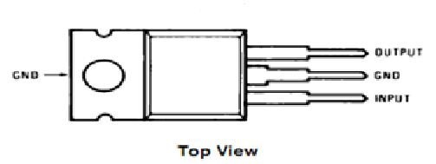
Fig. 3.4 Three-Terminal Voltage Regulators
Figure shows the basic connection of a three-terminal voltage regulator IC to a load. The fixed voltage regulator has an unregulated dc input voltage, V_{i}, applied to one input terminal, a regulated output dc voltage, V_{o}, from a second terminal, with the third terminal connected to ground. For a selected regulator, IC device specifications list a voltage range over which the input voltage can vary to maintain a regulated output voltage over a range of load current. The specifications also list the amount of output voltage change resulting from a change in load current (load regulation) or in input voltage (line regulation). The series 78 regulators provide fixed regulated voltages from 5 to 24 V. Figure shows how one such IC, a 7805, is connected to provide voltage regulation with output from this unit of +5V dc. An unregulated input voltage V is filtered by capacitor C1 and connected to the IC’s IN terminal. The IC’s OUT terminal provides a regulated + 12V which is filtered by capacitor C2 (mostly for any high-frequency noise). The third IC terminal is connected to ground (GND). While the input voltage may vary over some permissible voltage range, and the output load may vary over some acceptable range, the output voltage remains constant within specified voltage variation limits. These limitations are spelled out in the manufacturer’s specification sheets. There are two types of voltage regulator they are 78xx series and 79xx series.
- 78xx series
There are common configurations for 78xx ICs, including 7805 (5 V), 7806 (6 V), 7808 (8 V), 7809 (9 V), 7810 (10 V), 7812 (12 V), 7815 (15 V), 7818 (18 V), and 7824 (24 V) versions. The 7805 is the most common, as its regulated 5-volt supply provides a convenient power source for most TTL components.
Less common are lower-power versions such as the LM78Mxx series (500 mA) and LM78Lxx series (100 mA) from National Semiconductor. Some devices provide slightly different voltages than usual, such as the LM78L62 (6.2 volts) and LM78L82 (8.2 volts) as well as the STMicroelectronics L78L33ACZ (3.3 volts).
- 79xx series
The 79xx devices have a similar "part number" to "voltage output" scheme, but their outputs are negative voltage, for example 7905 is -5 V and 7912 is -12 V. The 7912 has been a popular component in ATX power supplies, and 7905 was popular component in ATX before -5 V was removed from the ATX specification.
IC Part | Output Voltage (V) | Vi (V)
7805 | +5 | 7.3
7806 | +6 | 8.3
7808 | +8 | 10.5
7810 | +10 | 12.5
7812 | +12 | 13.6
7815 | +15 | 17.7
7818 | +18 | 21.0
7824 | +24 | 27.1

Table 2 : Positive Voltage Regulators in 7800 series

- ESP32
ESP32-S3 is a low-power MCU-based system-on-chip (SoC) that supports 2.4 GHz Wi-Fi and Bluetooth® Low Energy (Bluetooth LE). It consists of high-performance dual-core microprocessor (Xtensa® 32-bit LX7), a low power coprocessor, a Wi-Fi baseband, a Bluetooth LE baseband, RF module, and peripherals. The block diagram of the SoC is shown below.
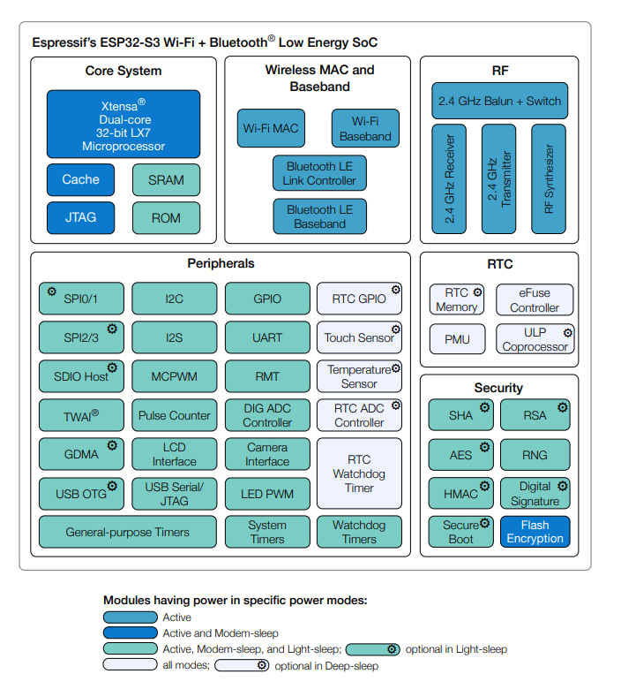
Fig 3.5 : Block Diagram of ESP32S3
- SOLUTION HIGHLIGHTS
- A complete WiFi subsystem that complies with IEEE 802.11b/g/n protocol and supports Station, SoftAP, and SoftAP + Station modes
- A Bluetooth LE subsystem that supports features of Bluetooth 5 and Bluetooth mesh
- Highly integrated RF module that provides industry-leading power and RF performance
- State of the art power management designed for a wide range of applications with its multiple low-power modes. The ULP coprocessor can operate in ultra-low-power mode.
- Powerful storage capacities ensured by 512 KB SRAM and 384 KB ROM on the chip, and SPI, Dual SPI, Quad SPI, Octal SPI, QPI, and OPI interfaces that allow connection to flash and external RAM
- Rich set of peripheral interfaces and GPIOs, ideal for various scenarios and complex applications
- FEATURES

- WiFi
- IEEE 802.11 b/g/n-compliant
- Supports 20 MHz, 40 MHz bandwidth in 2.4 GHz band
- Wi-Fi Multimedia (WMM)
- TX/RX A-MPDU, TX/RX A-MSDU
- Immediate Block ACK
- Fragmentation and defragmentation
- Automatic Beacon monitoring (hardware TSF)
- 4 × virtual Wi-Fi interfaces
- Simultaneous support for Infrastructure BSS in Station, SoftAP, or Station
- SoftAP modes Note that when ESP32-S3 scans in Station mode, the SoftAP channel will change along with the Station channel
- Antenna diversity
- 802.11mc FTM
- External PA is supported
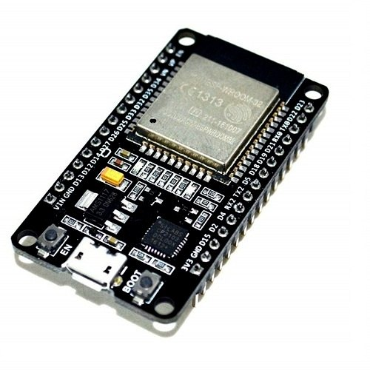
Fig.3.6 ESP32 - NodeMCU
- BLUETOOTH
- Bluetooth LE: Bluetooth 5, Bluetooth mesh
- High power mode (20 dBm, share the same PA with Wi-Fi)
- Speed: 125 Kbps, 500 Kbps, 1 Mbps, 2 Mbps
- Advertising extensions
- Multiple advertisement sets
- Channel selection algorithm #2
- Internal co-existence mechanism between Wi-Fi and Bluetooth to share the same antenna
- CPU AND MEMORY
- Xtensa® dual-core 32-bit LX7 microprocessor, up to 240 MHz
- CoreMark® score:
  - 1 core at 240 MHz: 613.86 CoreMark; 2.56 CoreMark/MHz
  - 2 cores at 240 MHz: 1181.60 CoreMark; 4.92 CoreMark/MHz
- 128-bit data bus and SIMD commands
- 384 KB ROM
- 512 KB SRAM
- 16 KB SRAM in RTC
- SPI, Dual SPI, Quad SPI, Octal SPI, QPI and OPI interfaces that allow connection to multiple flash and external RAM
- Flash controller with cache is supported
- Flash in-Circuit Programming (ICP) is supported
- ESP32 DEVKIT DOIT
ESP32 DEVKIT DOIT board as a reference. But the information on this page is also compatible with other ESP32 development boards with the ESP-WROOM-32 chip.
- SPECIFICATIONS
When it comes to the ESP32 chip specifications, find that:
- The ESP32 is dual core; this means it has 2 processors.
- It has Wi-Fi and bluetooth built-in.
- It runs 32 bit programs.
- The clock frequency can go up to 240MHz and it has a 512 kB RAM.
- This particular board has 30 or 36 pins, 15 in each row.
- It also has wide variety of peripherals available, like: capacitive touch, ADCs, DACs, UART, SPI, I2C and much more.
- It comes with built-in hall effect sensor and built-in temperature sensor.

- SPECIFICATIONS – ESP32 DEVKIT V1 DOIT
Number of cores 2 (dual core)
Wi-Fi 2.4 GHz up to 150 Mbits/s
Bluetooth BLE (Bluetooth Low Energy) and legacy Bluetooth
Architecture 32 bits
Clock frequency Up to 240 MHz
RAM 512 KB
Pins 30 or 36 (depends on the model)
Peripherals ADC (analog to digital converter),
DAC (digital to analog converter),
I2C (Inter-Integrated Circuit),
UART (universal asynchronous receiver/transmitter),
CAN 2.0 (Controller Area Network),
SPI (Serial Peripheral Interface),
I2S (Integrated Inter-IC Sound),
PWM (pulse width modulation), and more.
- ESP32 PINOUT GUIDE
The ESP32 has more GPIOs with more functionality compared to the ESP826. With the ESP32 you can decide which pins are UART, I2C, or SPI – you just need to set that on the code. This is possible due to the ESP32 chip’s multiplexing feature that allows to assign multiple functions to the same pin. If you don’t set them on the code, the pins will be used as default, as shown in the figure below (the pin location can change depending on the manufacturer).

The core of this module is the ESP32 chip, which is scalable and adaptive. Two CPU cores can be individually controlled. The clock frequency is adjustable from 80 MHz to 240 MHz and supports RTOS. It is a general-purpose Wi-Fi+BT+BLE MCU module.ESP-WROOM-32s. The module integrates traditional Bluetooth, Bluetooth low energy and Wi-Fi. Wide range of uses: Wi-Fi supports a wide range of communication connections, as well as direct connection to the Internet via a router; Bluetooth allows users to connect to a mobile phone or broadcast a BLE Beacon for signal detection. The module supports data rates up to 150 Mbps and antenna output power of 20 dBm for maximum wireless communication. As a result, this module has industry-leading specifications and performs well in terms of high integration, wireless transmission distance, power consumption, and network connectivity.
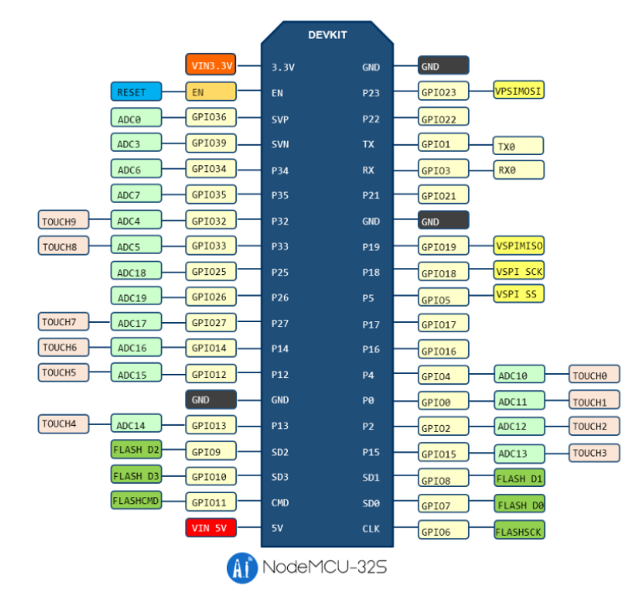
Fig.3.7 ESP32 V1.1 38Pin NodeMCU Pin Diagram
- HUMIDITY SENSOR
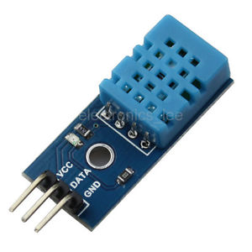
Fig 3.8 Humidity sensor
Humidity is the presence of water in air. The amount of water vapor in air can affect human comfort as well as many manufacturing processes in industries. The presence of water vapor also influences various physical, chemical, and biological processes. Humidity measurement in industries is critical because it may affect the business cost of the product and the health and safety of the personnel. Hence, humidity sensing is very important, especially in the control systems for industrial processes and human comfort.
Controlling or monitoring humidity is of paramount importance in many industrial & domestic applications. In semiconductor industry, humidity or moisture levels needs to be properly controlled & monitored during wafer processing. In medical applications, humidity control is required for respiratory equipments, sterilizers, incubators, pharmaceutical processing, and biological products. Humidity control is also necessary in chemical gas purification, dryers, ovens, film desiccation, paper and textile production, and food processing. In agriculture, measurement of humidity is important for plantation protection (dew prevention), soil moisture monitoring, etc. For domestic applications, humidity control is required for living environment in buildings, cooking control for microwave ovens, etc. In all such applications and many others, humidity sensors are employed to provide an indication of the moisture levels in the environment.
- Relevant Moisture Terms
To mention moisture levels, variety of terminologies are used. The study of water vapour concentration in air as a function of temperature and pressure falls under the area of psychometrics. Psychometrics deals with the thermodynamic properties of moist gases while the term “humidity’ simply refers to the presence of water vapour in air or other carrier gas.
Humidity measurement determines the amount of water vapor present in a gas that can be a mixture, such as air, or a pure gas, such as nitrogen or argon. Various terms used to indicate moisture levels are tabulated in the table below:
Most commonly used units for humidity measurement are Relative Humidity (RH), Dew/Frost point (D/F PT) and Parts Per Million (PPM). RH is a function of temperature, and thus it is a relative measurement. Dew/Frost point is a function of the pressure of the gas but is independent of temperature and is therefore defined as absolute humidity measurement. PPM is also an absolute measurement.
Dew points and frost points are often used when the dryness of the gas is important. Dew point is also used as an indicator of water vapor in high temperature processes, such as industrial drying.
Mixing ratios, volume percent, and specific humidity are usually used when water vapor is either an impurity or a defined component of a process gas mixture used in manufacturing.
- Humidity Sensing – Classification & Principles
According to the measurement units, humidity sensors are divided into two types: Relative humidity(RH)sensors and absolute humidity(moisture) sensors. Most humidity sensors are relative humidity sensors and use different sensing principles.
- Sensing Principle
Humidity measurement can be done using dry and wet bulb hygrometers, dew point hygrometers, and electronic hygrometers. There has been a surge in the demand of electronic hygrometers, often called humidity sensors. Electronic type hygrometers or humidity sensors can be broadly divided into two categories: one employs capacitive sensing principle, while other use resistive effects
- Sensors based on capacitive effect:
Humidity sensors relying on this principle consists of a hygroscopic dielectric material sandwiched between a pair of electrodes forming a small capacitor. Most capacitive sensors use a plastic or polymer as the dielectric material, with a typical dielectric constant ranging from 2 to 15. In absence of moisture, the dielectric constant of the hygroscopic dielectric material and the sensor geometry determine the value of capacitance.
At normal room temperature, the dielectric constant of water vapor has a value of about 80, a value much larger than the constant of the sensor dielectric material. Therefore, absorption of water vapor by the sensor results in an increase in sensor capacitance.
At equilibrium conditions, the amount of moisture present in a hygroscopic material depends on both the ambient temperature and the ambient water vapor pressure. This is true also for the hygroscopic dielectric material used on the sensor.
By definition, relative humidity is a function of both the ambient temperature and water vapor pressure. Therefore there is a relationship between relative humidity, the amount of moisture present in the sensor, and sensor capacitance. This relationship governs the operation of a capacitive humidity instrument.
- Gas Sensor
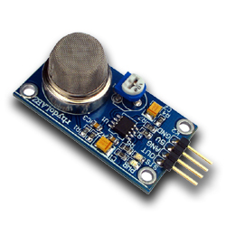
Fig.3.9 Gas sensor
Gas sensor is the device used for detecting the presence of Gases like Carbon monoxide, LPG, Ethanol, Toluene, Hydrogen etc. These are used as safety measures in work places and Home to avoid hazardous situations. The sensor can be used to generate an alarm or to activate a system to shut down the gas flow. Gas detectors are usually battery operated devices and if the gas level exceeds the preset level, it sends output signal to activate the circuit. Most commonly used gas sensors are LPG sensor, Smoke sensor and Alcohol sensor used in Breath analyzer.
Portable gas detectors are used to monitor rooms and the surroundings of human beings, Breath etc while fixed types are used for detecting one or more types of gases in factories , plants, hospitals etc.Fixed Smoke sensors are used in multistoried flats, shops etc. According to the mechanism of operation, Gas sensors may be Semiconductor, Catalytic, Oxidation and Infrared types.
- Working
The Gas sensor has a sensing element, a base and a cap. The sensing element has a sensing material ( Usually a Semiconductor) and a heater to heat up the sensing material. The different sensing materials used are Tin Oxide, Tungsten oxide etc depending on the type of gas to be sensed. In principle, when the Tin Oxide is heated to high temperature, it adsorbs oxygen on its surface with a negative charge. Then the donor electrons from the Tin oxide crystals passes into the adsorbed oxygen leaving the positive charge in a space charge layer. This creates a surface potential which prevents electron flow. Inside the sensor, the current flows through the boundary of Tin oxide crystals. In the boundary of the crystals, the adsorbed oxygen forms a barrier to prevent the free movement of carriers. This potential barrier gives the electrical resistance to the sensor.
So in the standby mode the electrical resistance of the sensor is high. In the presence of a De-Oxidizing gas, the surface density of the adsorbed negatively charged oxygen decreases leading to a reduction in the size of the barrier. This reduced barrier decreases the electrical resistance of the Sensor.
- Catalytic Sensors
These are mainly used for Combustible gas detection. These are electro catalytic types having a small sensing element called bead. The bead is made up of platinum wire coil covered with alumina and then with a coating of Palladium or Rhodium.The sensor element remains heated in the standby mode. When the combustible gas passes over the hot catalytic surface, combustion occurs and the temperature of the bead increases. This alters the resistance of the platinum coil in the bead. This resistance change is directly proportional to the concentration of gas.
MQ 6 Gas sensor is used as LPG, Butane and Propane Sensor to generate alarm when there is leakage of these gases from the source. MQ6 is a highly sensitive gas sensor to petroleum based gases but less sensitive to Alcohol and Carbon di oxide. This simple sensor can be installed in the kitchen to give warning alarm if there is leakage of LPG.
MQ6 gas sensor is a 6 pin device and it requires 5 volt DC maximum which is derived from a Zener based power supply. There is a heating element inside the sensor which becomes hot at 5 volt and remains stand by. When the sensor detects gas molecules between 100 ppm to 1000 ppm, in the atmosphere, its output turns high and triggers T1 to activate the buzzer. Red LED indicates the high output from the sensor.
- Pin configuration
These are sensitive semiconductor Gas sensors that give an analog voltage at the output when the air contains Combustible gas molecules. In clean air, it gives low voltage and when the gas concentration increases, output voltage also increases accordingly.
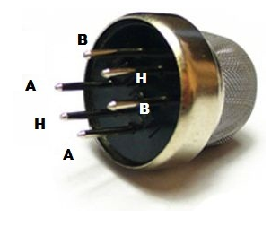
Fig. 3.10 Pin configuration
- The Sensors are provided with 6 pins but 4 pins are sufficient for connection.
- H-H pins – These are used for providing 5V DC to the heater element. These pins have no polarity and one H can be connected to 5V DC and the other to the ground
- Pins A – A (or B-B). The A and B pins can be used for providing 5 V DC or to get output voltage. If the pins A are used ( by shorting), pins B( by shorting) act as the output or Vice versa.
- Sensitive material of MQ-6 gas sensor is SnO2, which with lower conductivity in clean air. When the target combustible gas exist, the sensors conductivity is more higheralong with the gas concentration rising. Please use simple electro circuit, Convert change of conductivity to correspond output signal of gas concentration.
- MQ-6 gas sensor has high sensitivity to Propane, Butane and LPG, also response to Natural gas. The sensor could be used to detect different combustible gas, especially Methane; it is with low cost and suitable for different application.
- Character
- High sensitivity to Combustible gas in wide range
- High sensitivity to Propane, Butane and LPG
- Fast response
- Wide detection range
- Stable performance, long life, low cost
- Simple drive circuit

CHAPTER 4
PROGRAM DESIGN
- MODULES
- Gas Detection Module (CO2 & CH4)
- Water Level Monitoring Module
- IR Sensor-Based Manhole Cover Status Detection Module
- Humidity Sensing Module
- Alert and Notification Module (Buzzer & NodeMCU Alerts)
- Display Module (I2C LCD Display)
- Central Control and Data Processing Module (Arduino Uno / NodeMCU)
- MODULES DESCRIPTION
- GAS DETECTION MODULE (CO2 & CH4):
This module is responsible for monitoring the presence of hazardous gases inside the manhole. CO2 and Methane (CH4) sensors are deployed to detect toxic and combustible gases that may pose risks to workers or nearby residents. The sensors measure gas concentration continuously and generate analog signals corresponding to the detected levels. These analog signals are then converted into digital values using the Arduino’s ADC (Analog-to-Digital Converter). If gas levels exceed the predefined safety threshold, the module triggers an alert through the buzzer and sends a signal to the central control system. The module ensures early detection of dangerous gas buildup, reducing the risk of accidents. It is calibrated to detect even small variations in gas concentration. The sensors are low-cost, reliable, and have high sensitivity. This module forms the core safety mechanism of the system. Real-time gas monitoring data can also be transmitted to remote monitoring systems via NodeMCU. It provides both local and remote alert capabilities. By integrating with other modules, it contributes to overall smart city safety.

- WATER LEVEL MONITORING MODULE:
The water level sensor monitors the liquid level inside manholes to detect potential flooding or overflow. It helps identify blockages, sewer backups, or unusual water accumulation. The sensor sends continuous readings to the Arduino, which compares the water level against predefined safety thresholds. When the water exceeds safe limits, the system immediately triggers an alarm to warn workers and authorities. This module prevents accidents due to sudden flooding. The sensor works in both clean and dirty water environments, making it suitable for sewer monitoring. It can detect gradual water rise or sudden surges. Data from the water level sensor is displayed on the LCD for on-site operators. Alerts can also be sent remotely via NodeMCU for timely action. The system’s responsiveness ensures real-time hazard detection. It minimizes manual inspection requirements, enhancing operational efficiency. The module is compact, reliable, and easy to integrate with other sensors.
- IR SENSOR-BASED MANHOLE COVER STATUS DETECTION MODULE:
This module uses IR sensors to detect whether a manhole cover is open or closed. The IR sensor emits infrared light and detects reflection or interruption to determine the cover status. If the cover is lifted accidentally or tampered with, the sensor triggers an alert. This helps prevent accidental falls and unauthorized access. The sensor continuously monitors the manhole cover and provides real-time data to the Arduino. The system can differentiate between normal opening and suspicious activity. It displays the cover status on the LCD screen for operators. The IR sensor module ensures preventive safety measures. Alerts can also be transmitted remotely via NodeMCU for immediate response. This module enhances security around urban drainage systems. It is low-power and easy to deploy at multiple nodes. Integration with other modules ensures comprehensive monitoring.
- HUMIDITY SENSING MODULE:
The humidity sensor monitors moisture levels inside the manhole environment. High humidity can indicate water seepage or increased risk of gas buildup due to condensation. The sensor sends analog readings to the Arduino, which processes the data in real-time. If abnormal humidity levels are detected, the system logs the data and triggers alerts. Monitoring humidity is crucial for maintaining structural integrity and worker safety. Data is displayed on the LCD and can also be transmitted via NodeMCU. This module ensures environmental conditions inside manholes are continuously assessed. It helps predict potential corrosion or degradation of manhole infrastructure. The sensor is compact, low-cost, and highly sensitive. Continuous monitoring allows for early preventive measures. This module works in tandem with gas and water level sensors for comprehensive hazard detection.

- ALERT AND NOTIFICATION MODULE (BUZZER & NODEMCU ALERTS):
The alert module provides real-time warnings to both local personnel and remote supervisors. A buzzer immediately sounds if any abnormal condition is detected, such as high gas levels, flooding, or manhole cover tampering. NodeMCU transmits sensor data and alert notifications to a remote monitoring platform or mobile device. This ensures timely response and quick mitigation of hazardous situations. The module allows emergency signals to be sent automatically without manual intervention. It enhances safety by reducing response time in critical conditions. Integration with multiple sensors ensures all hazards trigger alerts efficiently. The system supports SMS or cloud-based notifications if connected. The alert module is simple, low-power, and reliable. It is vital for minimizing accidents and protecting workers. Continuous testing ensures the buzzer and alerts function under all conditions. The module is fully integrated with the system’s central control.
- DISPLAY MODULE (I2C LCD DISPLAY):
The I2C LCD display module provides real-time visualization of all sensor readings. It shows gas levels, water levels, humidity, manhole status, and worker heartbeat. Operators can quickly interpret the current status of each monitored parameter. The I2C interface reduces wiring complexity and allows easy integration with Arduino. This module ensures on-site personnel are informed of all critical conditions. Alerts are displayed alongside normal readings for immediate awareness. The LCD display aids in troubleshooting and maintenance activities. It supports continuous operation with minimal power consumption. The module provides clear and readable output in urban environments. Integration with the alert system ensures synchronized monitoring. It enhances operational transparency and reduces dependency on remote monitoring alone. The module is robust and suitable for harsh environmental conditions.
- CENTRAL CONTROL AND DATA PROCESSING MODULE (ARDUINO UNO / NODEMCU):
This module serves as the brain of the system, processing inputs from all sensors. Arduino Uno collects analog and digital data, executes threshold comparisons, and controls the alert and display modules. NodeMCU enables remote monitoring and data transmission over Wi-Fi or GSM. The system processes sensor data in real-time to ensure rapid response to hazardous conditions. It supports modular integration of multiple sensors across different nodes. The microcontroller executes embedded firmware for automated decision-making. Data logging and alert history are managed efficiently. The module provides centralized control over the entire monitoring system. It reduces manual intervention and improves system reliability. The design supports expansion for additional sensors or IoT integration. Safety protocols are implemented via software to prevent false alarms. Overall, it forms the core intelligence of the manhole monitoring system.

SOFTWARE DESIGN
- ARDUINO
Arduino is an open-source electronics platform based on easy-to-use hardware and software. Arduino boards are able to read inputs - light on a sensor, a finger on a button, or a Twitter message - and turn it into an output - activating a motor, turning on an LED, publishing something online. You can tell your board what to do by sending a set of instructions to the microcontroller on the board. To do so you use the Arduino programming language (based on Wiring), and the Arduino Software (IDE), based on Processing.
Over the years Arduino has been the brain of thousands of projects, from everyday objects to complex scientific instruments. A worldwide community of makers - students, hobbyists, artists, programmers, and professionals - has gathered around this open-source platform, their contributions have added up to an incredible amount of accessible knowledge that can be of great help to novices and experts alike.
Arduino was born at the Ivrea Interaction Design Institute as an easy tool for fast prototyping, aimed at students without a background in electronics and programming. As soon as it reached a wider community, the Arduino board started changing to adapt to new needs and challenges, differentiating its offer from simple 8-bit boards to products for IoT applications, wearable, 3D printing, and embedded environments. All Arduino boards are completely open-source, empowering users to build them independently and eventually adapt them to their particular needs. The software, too, is open-source, and it is growing through the contributions of users worldwide.
- FEATURES
- Inexpensive - Arduino boards are relatively inexpensive compared to other microcontroller platforms. The least expensive version of the Arduino module can be assembled by hand, and even the pre-assembled Arduino modules cost less than \$50.
- Cross-platform - The Arduino Software (IDE) runs on Windows, Macintosh OSX, and Linux operating systems. Most microcontroller systems are limited to Windows.
- Simple, clear programming environment - The Arduino Software (IDE) is easy-to-use for beginners, yet flexible enough for advanced users to take advantage of as well. For teachers, it's conveniently based on the Processing programming environment, so students learning to program in that environment will be familiar with how the Arduino IDE works.
- Open source and extensible software - The Arduino software is published as open source tools, available for extension by experienced programmers. The language can be expanded through C++ libraries, and people wanting to understand the technical details can make the leap from Arduino to the AVR C programming language on which it's based. Similarly, you can add AVR-C code directly into your Arduino programs if you want to.
- Open source and extensible hardware - The plans of the Arduino boards are published under a Creative Commons license, so experienced circuit designers can make their own version of the module, extending it and improving it. Even relatively inexperienced users can build the breadboard version of the module in order to understand how it works and save money.

- ARDUINO SOFTWARE (IDE)
The Arduino Integrated Development Environment - or Arduino Software (IDE) - contains a text editor for writing code, a message area, a text console, a toolbar with buttons for common functions and a series of menus. It connects to the Arduino hardware to upload programs and communicate with them.
- Writing Sketches
Programs written using Arduino Software (IDE) are called sketches. These sketches are written in the text editor and are saved with the file extension .ino. The editor has features for cutting/pasting and for searching/replacing text. The message area gives feedback while saving and exporting and also displays errors. The console displays text output by the Arduino Software (IDE), including complete error messages and other information. The bottom righthand corner of the window displays the configured board and serial port. The toolbar buttons allow you to verify and upload programs, create, open, and save sketches, and open the serial monitor.

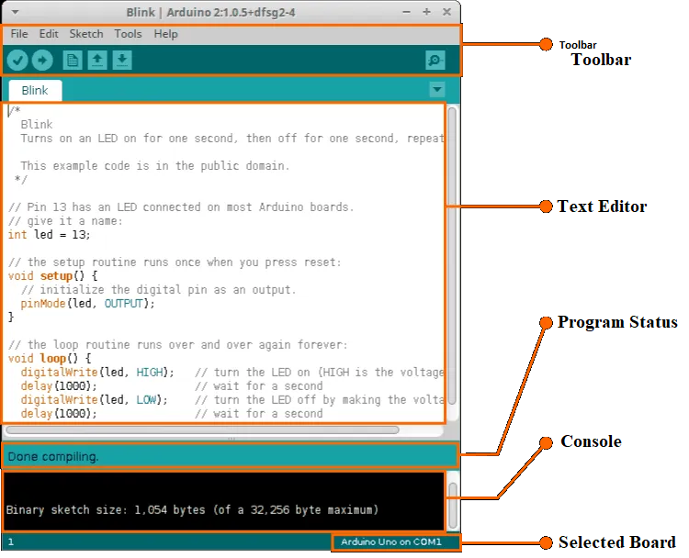
Fig.4.1 Arduino IDE
- Verify: Checks your code for errors, compiling it.
- Upload Compiles your code and uploads it to the configured board. See uploading below for details. Note: If you are using an external programmer with your board, you can hold down the "shift" key on your computer when using this icon. The text will change to "Upload using Programmer"
- New Creates a new sketch.
- Open Presents a menu of all the sketches in your sketchbook. Clicking one will open it within the current window overwriting its content.
- Save Saves your sketch.
- SerialMonitor Opens the serial monitor.

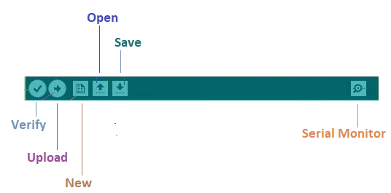
Fig.4.2 Arduino IDE Tool Icon
Additional commands are found within the five menus: File, Edit, Sketch, Tools, Help. The menus are context sensitive, which means only those items relevant to the work currently being carried out are available.
- File
- New Creates a new instance of the editor, with the bare minimum structure of a sketch already in place.
- Open Allows to load a sketch file browsing through the computer drives and folders.
- Open Recent Provides a short list of the most recent sketches, ready to be opened.
- Sketchbook Shows the current sketches within the sketchbook folder structure; clicking on any name opens the corresponding sketch in a new editor instance.
- Examples Any example provided by the Arduino Software (IDE) or library shows up in this menu item. All the examples are structured in a tree that allows easy access by topic or library.
- Close Closes the instance of the Arduino Software from which it is clicked.
- Save Saves the sketch with the current name. If the file hasn't been named before, a name will be provided in a "Save as.." window.
- Save as... Allows to save the current sketch with a different name.
- Page Setup It shows the Page Setup window for printing.
- Print Sends the current sketch to the printer according to the settings defined in Page Setup.
- Preferences Opens the Preferences window where some settings of the IDE may be customized, as the language of the IDE interface.
- Quit Closes all IDE windows. The same sketches open when Quit was chosen will be automatically reopened the next time you start the IDE.
- Edit
- Undo/Redo Goes back of one or more steps you did while editing; when you go back, you may go forward with Redo.
- Cut Removes the selected text from the editor and places it into the clipboard.
- Copy Duplicates the selected text in the editor and places it into the clipboard.
- Copy for Forum Copies the code of your sketch to the clipboard in a form suitable for posting to the forum, complete with syntax coloring.
- Copy as HTML Copies the code of your sketch to the clipboard as HTML, suitable for embedding in web pages.
- Paste Puts the contents of the clipboard at the cursor position, in the editor.
- Select All Selects and highlights the whole content of the editor.
- Comment/Uncomment Puts or removes the // comment marker at the beginning of each selected line.
- Increase/Decrease Indent Adds or subtracts a space at the beginning of each selected line, moving the text one space on the right or eliminating a space at the beginning.
- Find Opens the Find and Replace window where you can specify text to search inside the current sketch according to several options.
- Find Next Highlights the next occurrence - if any - of the string specified as the search item in the Find window, relative to the cursor position.
- Find Previous Highlights the previous occurrence - if any - of the string specified as the search item in the Find window relative to the cursor position.

- Sketch
- Verify/Compile Checks your sketch for errors compiling it; it will report memory usage for code and variables in the console area.
- Upload Compiles and loads the binary file onto the configured board through the configured Port.
- Upload Using Programmer This will overwrite the bootloader on the board; you will need to use Tools > Burn Bootloader to restore it and be able to Upload to USB serial port again. However, it allows you to use the full capacity of the Flash memory for your sketch. Please note that this command will NOT burn the fuses. To do so a Tools -> Burn Bootloader command must be executed.
- Export Compiled Binary Saves a .hex file that may be kept as archive or sent to the board using other tools.
- Show Sketch Folder Opens the current sketch folder.
- Include Library Adds a library to your sketch by inserting #include statements at the start of your code. For more details, see libraries below. Additionally, from this menu item you can access the Library Manager and import new libraries from .zip files. Add File... Adds a source file to the sketch (it will be copied from its current location). The new file appears in a new tab in the sketch window. Files can be removed from the sketch using the tab menu accessible clicking on the small triangle icon below the serial monitor one on the right side o the toolbar.
- Tools
- Auto Format This formats your code nicely: i.e. indents it so that opening and closing curly braces line up, and that the statements inside curly braces are indented more.
- Archive Sketch Archives a copy of the current sketch in .zip format. The archive is placed in the same directory as the sketch.
- Fix Encoding & Reload Fixes possible discrepancies between the editor char map encoding and other operating systems char maps.
- Serial Monitor Opens the serial monitor window and initiates the exchange of data with any connected board on the currently selected Port. This usually resets the board, if the board supports Reset over serial port opening.
- Board Select the board that you're using. See below for descriptions of the various boards.
- Port This menu contains all the serial devices (real or virtual) on your machine. It should automatically refresh every time you open the top-level tools menu.
- Programmer For selecting a hardware programmer when programming a board or chip and not using the onboard USB-serial connection. Normally you won't need this, but if you're burning a bootloader to a new microcontroller, you will use this.
- Burn Bootloader The items in this menu allow you to burn a bootloader onto the microcontroller on an Arduino board. This is not required for normal use of an Arduino board but is useful if you purchase a new ATmega microcontroller (which normally comes without a bootloader). Ensure that you've selected the correct board from the Boards menu before burning the bootloader on the target board. This command also set the right fuses.
- Help
Here you find easy access to a number of documents that come with the Arduino Software (IDE). You have access to Getting Started, Reference, this guide to the IDE and other documents locally, without an internet connection. The documents are a local copy of the online ones and may link back to our online website. Find in Reference This is the only interactive function of the Help menu: it directly selects the relevant page in the local copy of the Reference for the function or command under the cursor.

- Sketchbook
The Arduino Software (IDE) uses the concept of a sketchbook: a standard location to save your programs (or sketches). You can open sketches from your sketchbook via the File > Sketchbook menu or by clicking the Open button on the toolbar. When you run the Arduino software for the first time, it automatically creates a directory for your sketchbook. You can view or change the sketchbook location in the Preferences dialog.
- Tabs, Multiple Files, and Compilation
Allows you to manage sketches with more than one file (each of which appears in its own tab). These can be normal Arduino code files (no visible extension), C files (.c extension), C++ files (.cpp), or header files (.h).
Before compiling the sketch, all the normal Arduino code files of the sketch (.ino, .pde) are concatenated into a single file following the order the tabs are shown in. The other file types are left as is.
- Uploading
Before uploading your sketch, you need to select the correct items from the Tools > Board and Tools > Port menus. The boards are described below. On the Mac, the serial port is probably something like /dev/tty.usbmodem241 (for an Uno or Mega2560 or Leonardo) or /dev/tty.usbserial-1B1 (for a Duemilanove or earlier USB board), or /dev/tty.USA19QW1b1P1.1 (for a serial board connected with a Keyspan USB-to-Serial adapter). On Windows, it's probably COM1 or COM2 (for a serial board) or COM4, COM5, COM7, or higher (for a USB board) - to find out, you look for USB serial device in the ports section of the Windows Device Manager. On Linux, it should be /dev/ttyACMx , /dev/ttyUSBx or similar. Once you've selected the correct serial port and board, press the upload button in the toolbar or select the Upload item from the Sketch menu. Current Arduino boards will reset automatically and begin the upload. With older boards (pre-Diecimila) that lack auto-reset, you'll need to press the reset button on the board just before starting the upload. On most boards, you'll see the RX and TX LEDs blink as the sketch is uploaded. The Arduino Software (IDE) will display a message when the upload is complete or show an error.
When you upload a sketch, you're using the Arduino bootloader, a small program that has been loaded on to the microcontroller on your board. It allows you to upload code without using any additional hardware. The bootloader is active for a few seconds when the board resets; then it starts whichever sketch was most recently uploaded to the microcontroller. The bootloader will blink the on-board (pin 13) LED when it starts (i.e. when the board resets).

- Libraries
Libraries provide extra functionality for use in sketches, e.g. working with hardware or manipulating data. To use a library in a sketch, select it from the Sketch > Import Library menu. This will insert one or more #include statements at the top of the sketch and compile the library with your sketch. Because libraries are uploaded to the board with your sketch, they increase the amount of space it takes up. If a sketch no longer needs a library, simply delete its #include statements from the top of your code.
There is a list of libraries in the reference. Some libraries are included with the Arduino software. Others can be downloaded from a variety of sources or through the Library Manager. Starting with version 1.0.5 of the IDE, you do can import a library from a zip file and use it in an open sketch. See these instructions for installing a third-party library.
- Third-Party Hardware
Support for third-party hardware can be added to the hardware directory of your sketchbook directory. Platforms installed there may include board definitions (which appear in the board menu), core libraries, bootloaders, and programmer definitions. To install, create the hardware directory, then unzip the third-party platform into its own sub-directory. (Don't use "arduino" as the sub-directory name or you'll override the built-in Arduino platform.) To uninstall, simply delete its directory.
- Serial Monitor
This displays serial sent from the Arduino board over USB or serial connector. To send data to the board, enter text and click on the "send" button or press enter. Choose the baud rate from the drop-down menu that matches the rate passed to Serial.begin in your sketch. Note that on Windows, Mac or Linux the board will reset (it will rerun your sketch) when you connect with the serial monitor. Please note that the Serial Monitor does not process control characters; if your sketch needs a complete management of the serial communication with control characters, you can use an external terminal program and connect it to the COM port assigned to your Arduino board.

- Preferences
Some preferences can be set in the preferences dialog (found under the Arduino menu on the Mac, or File on Windows and Linux). The rest can be found in the preferences file, whose location is shown in the preference dialog.
- Boards
The board selection has two effects: it sets the parameters (e.g. CPU speed and baud rate) used when compiling and uploading sketches; and sets and the file and fuse settings used by the burn bootloader command. Some of the board definitions differ only in the latter, so even if you've been uploading successfully with a particular selection you'll want to check it before burning the bootloader.
Arduino Software (IDE) includes the built in support for the boards in the following list, all based on the AVR Core. The Boards Manager included in the standard installation allows to add support for the growing number of new boards based on different cores like Arduino Due, Arduino Zero, Edison, Galileo and so on.

- STARTED WITH THE ARDUINO
The Arduino Nano is a small, complete, and breadboard-friendly board based on the ATmega328P. It offers the same connectivity and specs of the UNO board in a smaller form factor.
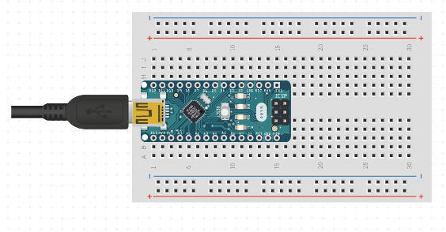

Fig.4.3 Arduino nano microcontroller
- Arduino NANO Interface
The Arduino Nano is programmed using the Arduino Software (IDE), our Integrated Development Environment common to all our boards and running both online and offline. For more information on how to get started with the Arduino Software visit the Getting Started page.
Open your first sketch
- Open the LED blink example sketch: File > Examples > 01.Basics > Blink.
Select your board type and port
- Select Tools > Board > Arduino AVR Boards > Arduino Nano.
NOTE: We have updated the Nano board with a fresh bootloader. Boards sold by us from January 2018 have this new bootloader, while boards manufactured before that date have the old bootloader. First, check that Tools > Board > Boards Manager shows you have the Arduino AVR Boards 1.16.21 or later installed. Then, to program the NEW Arduino NANO boards you need to choose Tools > Processor > ATmega328P. To program old boards you need to choose Tools > Processor > ATmega328P (Old Bootloader). If you get an error while uploading or you are not sure which bootloader you have, try each Tools > Processor menu option until your board gets properly programmed.
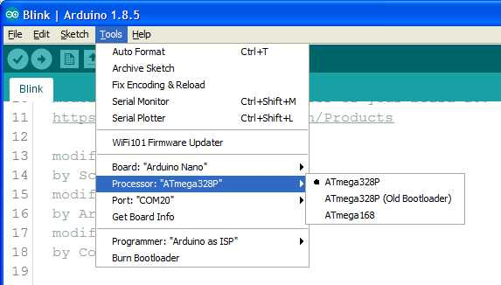
Fig. 4.4 Select the NANO Processor Type
Select the serial device of the board from the Tools | Serial Port menu. This is likely to be COM3 or higher (COM1 and COM2 are usually reserved for hardware serial ports). To find out, you can disconnect your board and re-open the menu; the entry that disappears should be the Arduino board. Reconnect the board and select that serial port.
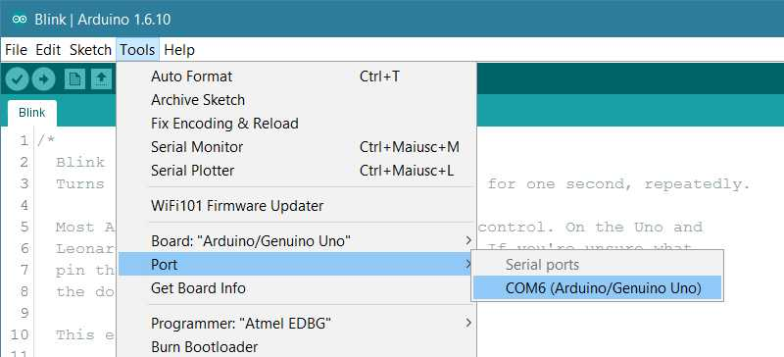
Fig.4.5 Select Board Type
Upload and Run your first Sketch
To upload the sketch to the Arduino Nano, click the Upload button in the upper left to load and run the sketch on your board:
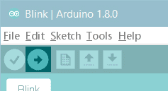
Fig.4.6 Upload to Nano
Wait a few seconds - you should see the RX and TX LEDs on the board flashing. If the upload is successful, the message "Done uploading." will appear in the status bar.

CHAPTER 5
TESTING
Testing can never completely identify all the defects within software. Instead, it furnishes a criticism or comparison that compares the state and behaviour of the product against oracles principles or mechanisms by which someone might recognize a problem. These oracles may include (but are not limited to) specifications, contracts, comparable products, past versions of the same product, inferences about intended or expected purpose, user or customer expectations, relevant standards, applicable laws, or other criteria. A primary purpose of testing is to detect software failures so that defects may be discovered and corrected. Testing cannot establish that a product functions properly under all conditions but can only establish that it does not function properly under specific conditions.
The scope of software testing often includes examination of code as well as execution of that code in various environments and conditions as well as examining the aspects of code: does it do what it is supposed to do and do what it needs to do. In the current culture of software development, a testing organization may be separate from the development team. There are various roles for testing team members. Information derived from software testing may be used to correct the process by which software is developed. Every software product has a target audience. For example, the audience for video game software is completely different from banking software. Therefore, when an organization develops or otherwise invests in a software product, it can assess whether the software product will be acceptable to its end users, its target audience, its purchasers, and other stakeholders. Software testing is the process of attempting to make this assessment
TESTING OBJECTIVES
The objective of testing is to systematically evaluate a system or application to ensure it functions as intended, meets specified requirements, and is free from defects. It involves identifying and correcting errors, validating performance, verifying functionality, and ensuring reliability, security, and usability under various conditions. Testing aims to enhance software quality, minimize risks, and ensure that the end product delivers a seamless and accurate user experience. It plays a critical role in the development lifecycle by detecting bugs early, reducing maintenance costs, and ensuring customer satisfaction.
SOFTWARE TESTING STRATEGIES
- UNIT TESTING
Unit testing involves the design of test cases that validate that the internal program logic is functioning properly, and that program inputs produce valid outputs. All decision branches and internal code flow should be validated. It is the testing of individual software units of the application. It is done after the completion of an individual unit before integration. This is a structural testing, that relies on knowledge of its construction and is invasive. Unit tests perform basic tests at component level and test a specific business process, application, and/or system configuration. Unit tests ensure that each unique path of a business process performs accurately to the documented specifications and contains clearly defined inputs and expected results.
- FUNCTIONAL TESTING
Functional tests provide systematic demonstrations that functions tested are available as specified by the business and technical requirements, system documentation, and user manuals.
Functional testing is centered on the following items:
Valid Input : identified classes of valid input must be accepted.
Invalid Input : identified classes of invalid input must be rejected.
Functions : identified functions must be exercised.
Output : identified classes of application outputs must be exercised.
Systems/Procedures: interfacing systems or procedures must be invoked.
Organization and preparation of functional tests is focused on requirements, key functions, or special test cases. In addition, systematic coverage pertaining to identify Business process flows; data fields, predefined processes, and successive processes must be considered for testing. Before functional testing is complete, additional tests are identified and the effective value of current tests is determined.
- ACCEPTANCE TESTING
User Acceptance Testing is a critical phase of any project and requires significant participation by the end user. It also ensures that the system meets the functional requirements.
- VALIDATION TESTING
At the culmination of integration testing, software is completely assembled as a package, interfacing errors have been uncovered and corrected, and a final series of software tests-validation testing begin. Validation can be defined in many ways, but a simple definition is that validation succeeds when software functions in a manner that can be reasonably expected by the customer.
- INTEGRATION TESTING
Integration testing is any type of software testing that seeks to verify the interfaces between components against a software design. Software components may be integrated in an iterative way or all together ("big bang"). Normally the former is considered a better practice since it allows interface issues to be localised more quickly and fixed. Integration testing works to expose defects in the interfaces and interaction between integrated components (modules). Progressively larger groups of tested software components corresponding to elements of the architectural design are integrated and tested until the software works as a system.

CHAPTER 6
CONCLUSION
The Manhole Monitoring System successfully demonstrates a cost-effective and efficient approach to enhancing urban safety and infrastructure management. By integrating multiple sensors such as gas detectors, water level sensors, humidity sensors, IR sensors, and heartbeat monitoring, the system provides comprehensive real-time monitoring of hazardous conditions in manholes. The use of Arduino Uno and NodeMCU as central control units ensures rapid data processing, local alerts via buzzer, and remote notifications to authorized personnel. This automated system minimizes reliance on manual inspections, reduces human errors, and enables quick responses to critical situations, thereby preventing accidents, toxic exposure, or infrastructure damage. The integration of an I2C LCD display allows on-site operators to easily interpret sensor readings, while NodeMCU facilitates remote supervision and alerts, aligning with the objectives of smart city applications.
Moreover, the modular and scalable design of the system allows easy expansion and integration with IoT platforms, cloud monitoring, or GSM modules for SMS alerts. It not only ensures the safety of municipal workers but also protects the general public by detecting potential hazards early. Monitoring worker health through heartbeat sensors adds an additional layer of safety, ensuring that personnel operating in risky environments are continuously tracked. Overall, this project highlights the importance of automated detection systems in urban infrastructure management. It provides a reliable, low-power, and user-friendly solution that enhances maintenance efficiency, reduces emergency response time, and contributes to creating safer, smarter, and more resilient urban environments.

CHAPTER 7
REFERENCES
- Ruheena.S, & Shereen.M, “IoT Based Manhole Detection and Monitoring System”, International Research Journal of Modern Engineering and Technology Science (IRJMETS)2024.
- Amutha. R, Kamali.S, & Sherli, “ Smart Manhole Managing and Monitoring System using IoT”, European Alliance for Innovation (EUDL)2022.
- Ojha V. K ,Dutta.P, & Singh. A, “IoT-Based Smart Manhole Monitoring System for Urban Drainage Safety”, International Journal of Innovative Technology and Exploring Engineering (IJITEE)2022.
- Kumar. R, & Karthik .S, “ Design and Implementation of Smart Manhole Monitoring with Gas and Water Level Detection Using IoT”,International Journal of Scientific Research in Engineering and Management (IJSREM)2023.
- Chowdhury .T, & Ahmed. F , “An Intelligent IoT-based Manhole Monitoring System for Detecting Gas Leakage and Water Overflow”,International Journal of Advanced Research in Electrical, Electronics and Instrumentation Engineering (IJAREEIE)2020.
- Patel. H & Mehta. K , “ IoT Enabled Smart Manhole Monitoring and Alert System for Urban Safety”.. International Journal of Engineering Research & Technology (IJERT)2023.
- Bhosale.P & Pawar.S ,“ Smart Manhole Detection System Using IoT for Water and Gas Level Monitoring”,International Journal of Recent Technology and Engineering (IJRTE)2022.
- Kumari.N, & Raj.R,“ Design of an IoT Based Smart Manhole Monitoring System with Real-Time Gas and Flood Detection”,International Journal of Innovative Research in Computer and Communication Engineering (IJIRCCE)2021.
- Kumar.A & Sharma.P, “ Automated Manhole Monitoring System Using IoT for Detection of Hazardous Gases and Water Levels”,IEEE Xplore Conference on Smart Technologies for Industrial Applications (STIA)2020.
- Jadhav.R & Patil.V, “ IoT Based Smart Manhole Monitoring System with Gas and Water Level Sensing”,International Journal of Emerging Trends in Engineering Research (IJETER)2023.

